Students in Dalian Medical University were grouped into different classes based on their majors once enrollment started. The samples taken in this experiment include four classes from the major of clinical medicine, one class from (中西医结合), and one class from （预防医学）. Before assigning them into CBL course group or control group (你还需要在之前详细介绍一下CBL group 和 control group具体都干啥), a preliminary test were given to these students to exclude any potential factors that affect students’ test score. The summaries of preliminary test were given below.

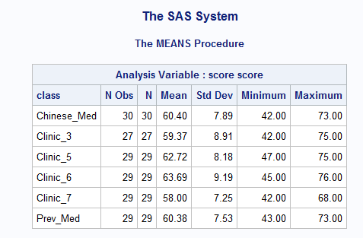

At first glance, there were no score differences between these classes. The boxplot for the six classes show the same thing.

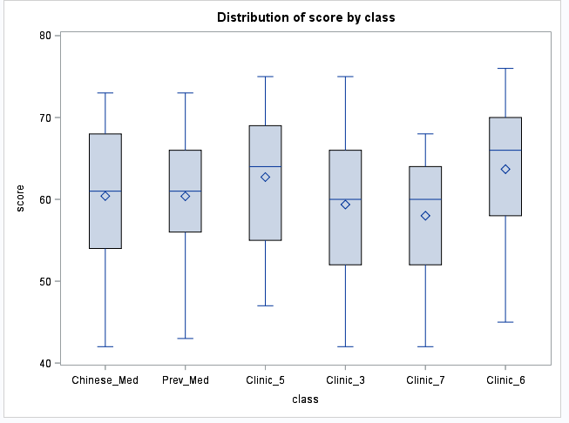

To make sure the slight differences in the score average between different classes have no statistical meaning, a Tukey’s test was performed. From the results below, none of the comparisons between two classes have significance when controlling the experimentwise error rate at 0.05.

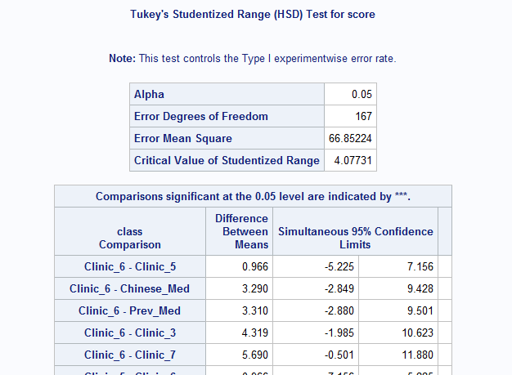

After the CBL course, we collected the biochemistry final test score for these students, and summarized their exam results.

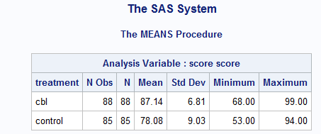

The boxplot below shows the same thing.

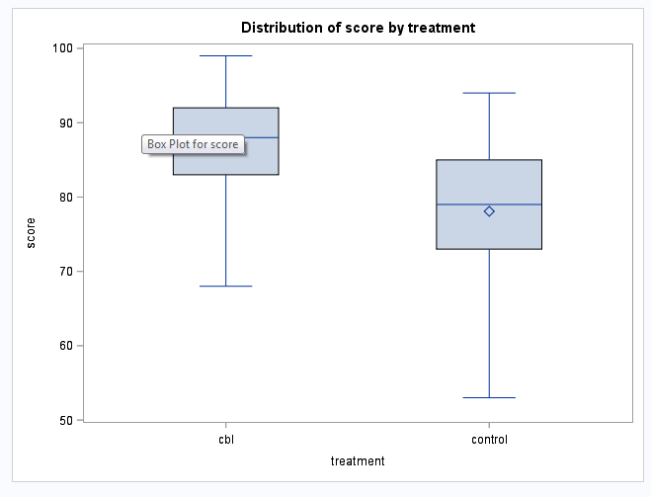

A further t test was conducted, a very small p value (<0.001) indicates that there’s a significant difference between these two groups.

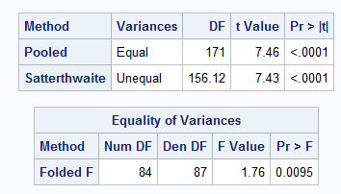

Even though the Q-Q plot is slightly tilted, the samples in general follows a normal distribution, thus validated our use of t test in this case.

